Douglas County Libraries
Battle of the Books 2015
Book List 3rd & 4th Grade

Title and Author |  | Summary | Reading Level
Because of Winn-Dixie by Kate DiCamillo | 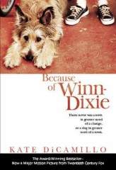 | 10-year-old India Opal Buloni, describes her first summer in the town of Naomi, Florida, and all the good things that happen to her because of her big ugly dog, ... | AR: 3.9  Lexile: 610  DRA 40
Fourth Grade Rats by Jerry Spinelli | 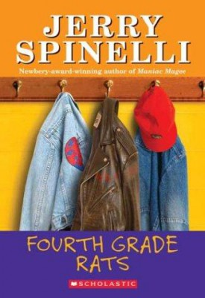 | Suds learns that his best friend is wrong. You don't have to be a tough guy, a "rat," to be a grown up fourth grader. | AR: 2.6  Lexile: 340  DRA 40
Frindle by Andrew Clements | 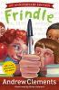 | When Nick Allen decides to turn his fifth-grade teacher's love of the dictionary around on her, he cleverly invents a new word and begins a chain of events that quickly moves beyond his control. | AR: 5.4  Lexile: 830  DRA 40
Help! I’m a Prisoner in the Library by Eth Clifford | 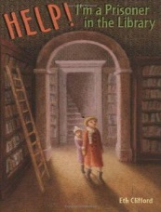 | Two girls spend an adventurous night trapped inside the public library during a terrible blizzard. | AR: 4.0  Lexile: 630  DRA 40
Number the Stars by Lois Lowery | 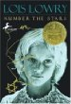 | In 1943, during the German occupation of Denmark, ten-year-old Annemarie learns how to be courageous when she helps shelter her Jewish friend from the Nazis. | AR: 4.5  Lexile: 670  DRA 50
One Crazy Summer by Rita Williams-Garcia | 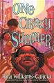 | In 1968, after traveling from Brooklyn to Oakland to spend a month with the mother they barely know, Delphine and her sisters arrive to a cold welcome as they discover their mother wants them to attend a Black Panther summer camp. | AR: 4.6  Lexile: 750  DRA 50

Title and Author |  |  | Summary | Reading Level
Rules by Cynthia Lord |  |  | Frustrated at life with an autistic brother, twelve-year-old Catherine longs for a normal existence, but her world is further complicated by a friendship with a teenage boy in a wheelchair. | AR: 3.9  Lexile: 780  DRA 40
The Secret Garden by Frances Hodgson Burnett | 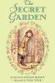 |  | Mary moves to a huge estate to live with her mysterious uncle, his ailing son, the servants--and a secret garden. | AR: 4.1  Lexile: 350  DRA 50
Turtle in Paradise by Jennifer L. Holm | 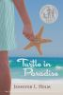 |  | In 1935, when her mother gets a job housekeeping for a woman who does not like children, eleven-year-old Turtle is sent to stay with relatives she has never met in faraway Key West, Florida. | AR: 3.7  Lexile: 610  DRA 40
White Fur Flying by Patricia MacLachlan |  |  | A sad and silent nine-year-old boy finds his voice when he moves next to a family who rescues dogs. | AR: 3.1  Lexile: 450  DRA 40

All these books are available at Douglas County Libraries as Your Lucky Day books.

Douglas County Libraries
Battle of the Books 2014
Book List 5th & 6th Grade

Title and Author |  | Summary | Reading Level
Because of Mr. Terupt by Rob Buyea | 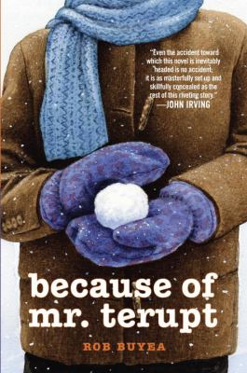 | Seven fifth-graders at Snow Hill School in Connecticut relate how their lives are changed for the better by rookie teacher Mr. Terupt. | AR: 3.7  Lexile: 350  DRA N/A
Bridge to Terabithia by Katherine Paterson | 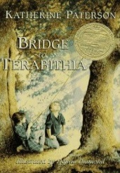 | The life of a ten-year-old boy in rural Virginia expands when he becomes friends with a newcomer, who subsequently meets an untimely death trying to reach their hideaway, Terabithia, during a storm. | AR: 4.6  Lexile: 810  DRA 50
Escaping the Giant Wave by Peg Kahret | 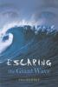 | When an earthquake creates a tsunami while thirteen-year-old Kyle is babysitting his sister during a family vacation at a Pacific Coast resort, he tries to save himself, his sister, and a boy who has bullied him for years. | AR: 4.7  Lexile: 750  DRA 40
Freak the Mighty by Rodman Philbrick | 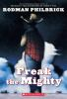 | At the beginning of eighth grade, learning disabled Max and his new friend Freak, whose birth defect has affected his body but not his brilliant mind, find that when they combine forces they make a powerful team. | AR: 5.5  Lexile: 1000  DRA 60
Mr. Popper’s Penguins by Richard and Florence Atwater |  | Mr. Popper trains his band of penguins to star in a vaudeville tour. | AR: 5.6  Lexile: 910  DRA 40

Title and Author |  | Summary | Reading Level
A Nest for Celeste: A story about art, inspiration and the meaning of home by Henry Cole | 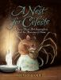 | Celeste, a mouse longing for a real home, becomes a source of inspiration to teenaged Joseph, assistant to the artist and naturalist John James Audubon, at a nearby Louisiana plantation in 1821. | AR: 5.1  Lexile: 730  DRA 50
Rebels of the Kasbah by Joe O’Neill | 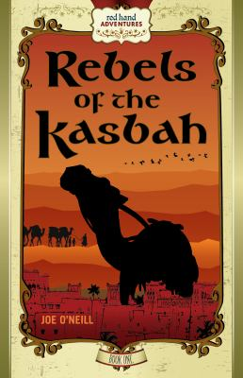 | Sold into slavery to compete in deadly camel races, Tarqi and his newfound friends must rely on their wits and each other to survive. | AR: N/A  Lexile: N/A  DRA N/A
Shooting Kabul by N.H. Senzai |  | Escaping from Taliban-controlled Afghanistan in the summer of 2001, 11-year-old Fadi and his family immigrate to California, where Fadi schemes to return to a Pakistani refugee camp to find his little sister, who was accidentally left behind. | AR: 5.4  Lexile: 800  DRA 50
The Watsons Go to Birmingham 1963: a novel by Christopher Paul Curtis |  | The ordinary interactions and everyday routines of the Watsons, an African American family living in Flint, Michigan, are drastically changed after they visit Grandma Sands in Alabama in the summer of 1963. | AR: 5.0  Lexile: 1000  DRA 50
Wonder by R.J. Palacio | 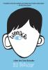 | Ten-year-old Auggie, born with extreme facial abnormalities, goes from being home-schooled to entering fifth grade at a private middle school, where he endures taunts and bullying and struggles to be seen as just another student. | AR: 4.8  Lexile: 790  DRA 50

All these books are available at Douglas County Libraries as Your Lucky Day books.

